|  |  |  |
| --- | --- | --- |
| Gear Shift | | |
| Game Design Document | | |
|  | | |
| A One-Button Mechanical Adventure | | |
|  | | |
|  | | |
| Art by Sebastian Beltran Convers | | |
| **Capybara Studios** | | |
| Andre Borja Miranda  Eduardo Cavalcante Almeida  Naomi Freire Nagayama  Sebastian Beltran Convers | | |
|  | | |
|  | | |
|  | Table of Contents  Overview 2  Description 2  Goals 2  Pillars 2  Hook 2  3 Cs 2  Character 2  Camera 2  Controls 2  Features 3  Toothed Surfaces 3  3  Smooth Surfaces 3  Spinners (GTH) 4  Bubble-gum 4  Shredders/Moving Enemies (GTH) 5  Production 6  Kanban Board 6  Team Members and Responsibilities 6  Risks and Mitigation 6  Publishing 6  Art 6  Tech 6  Audio 6  UI 7 |  |

# Overview

## Description

A 2D platformer where the player controls a cog within a machine by pressing a single button.

## Goals

This game, in essence a 2D platformer, provides us with the main goal of exploring the different sorts of maps that can be achieved when gravity in itself is a mechanic. We also hope to paint a picture of how that can be done by the implementation of a single button input.

## Pillars

Three pillars that will help inform your design decisions.

1. One Button – the game is supposed to take input from a single button. In our case, that button is ‘Space’ and the action attached to it is jumping.
2. Movement – the character slides through the surfaces at all times and the only player verb is jumping. These are the essential means of completing the game.
3. Satisfying – movement alone is aimed at being satisfying. Jumping from platform to platform, changing directions and collecting keys are all parts of an experience that should be as smooth and endorphin-inducing as possible.

## Hook

A 2D platformer with the twist of gravity as a core feature. Reach your objectives by spinning through all available surfaces.

# 3 Cs

## Character

A little cog named Coggi is an essential component of a Robot's heart. The Robot's condition has deteriorated over time due to the irregular amount of bubble gum spread across its surfaces.

The only way to clear out the bubble gum is by unlocking the tubes that connect the Robot’s organs and allowing to flow normally. Coggi is the only cog whose shape matches the keys needed to unlock these tubes.

Coggi's main mission is to find these keys by spinning through the surfaces, jumping between platforms and inverting the gravity to access different parts of each organ. This will all be done by automatic impulse and the press of a single button: 'Space' to jump.

## Camera

Side-view camera that follows Coggi across the levels.

## Controls

Spinning is the essence of Coggi’s movement. Coggi spins automatically. Tapping the SPACE button makes it jump.

# Features

## Toothed Surfaces

Metallic (brass), shiny, geometric. These are the surfaces which Coggi automatically spins through, as their shape match his. He travels in the same direction unless he collides with a different object or surface.

## Gravity Inverters

Gravity inversion is enabled by colliding with buttons that are displayed across the levels. The Gravity Inverters establish the gravity in four dimensions: Down, Up, Left and Right.

## Keys

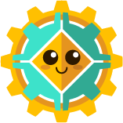The Keys are the collectibles needed to unlock the tubes and get through each level. Once picked up, they become a part of Coggi’s shape.

## Tubes

The tubes are located at the beginning and end of every level. The first one sets the starting position for Coggi and the second is blocked off until Coggi has acquired all the keys. Once he has all of them, he can go through, advancing to the next level, and leaving behind the keys that he found in the previous one.

## Bubble-gum

Pieces of pink gunk that are stuck on surfaces and once collided with, stop Cog’s movement entirely, essentially killing him. They are stationary.

# Production

## Kanban Board

Link to the board.

## Team Members and Responsibilities

|  |  |
| --- | --- |
| Team Member | Main Responsibilities |
| Andre Borja Miranda | Programming |
| Eduardo Cavalcante Almeida | Level Design |
| Naomi Freire Nagayama | Project Management, Art |
| Sebastian Beltran | Game Design, Art |

## Risks and Mitigation

Identify any risks and their possible mitigations. Add more rows as needed. Check example below.

|  |  |
| --- | --- |
| Risk | Mitigation(s) |
| Team has never made a game in two weeks | Establish priorities and work with them in mind from the start. Adding details only when prioritized tasks are completed. |
| Team has never made a one-button game | Work to tie all maps together by the use of the one button. |

## Publishing

A link to the itch.io game page.

# Art

Inspired mainly by moving pieces like those seen in watches, clocks and other machinery.

Steampunk elements converted to flat design aesthetic.

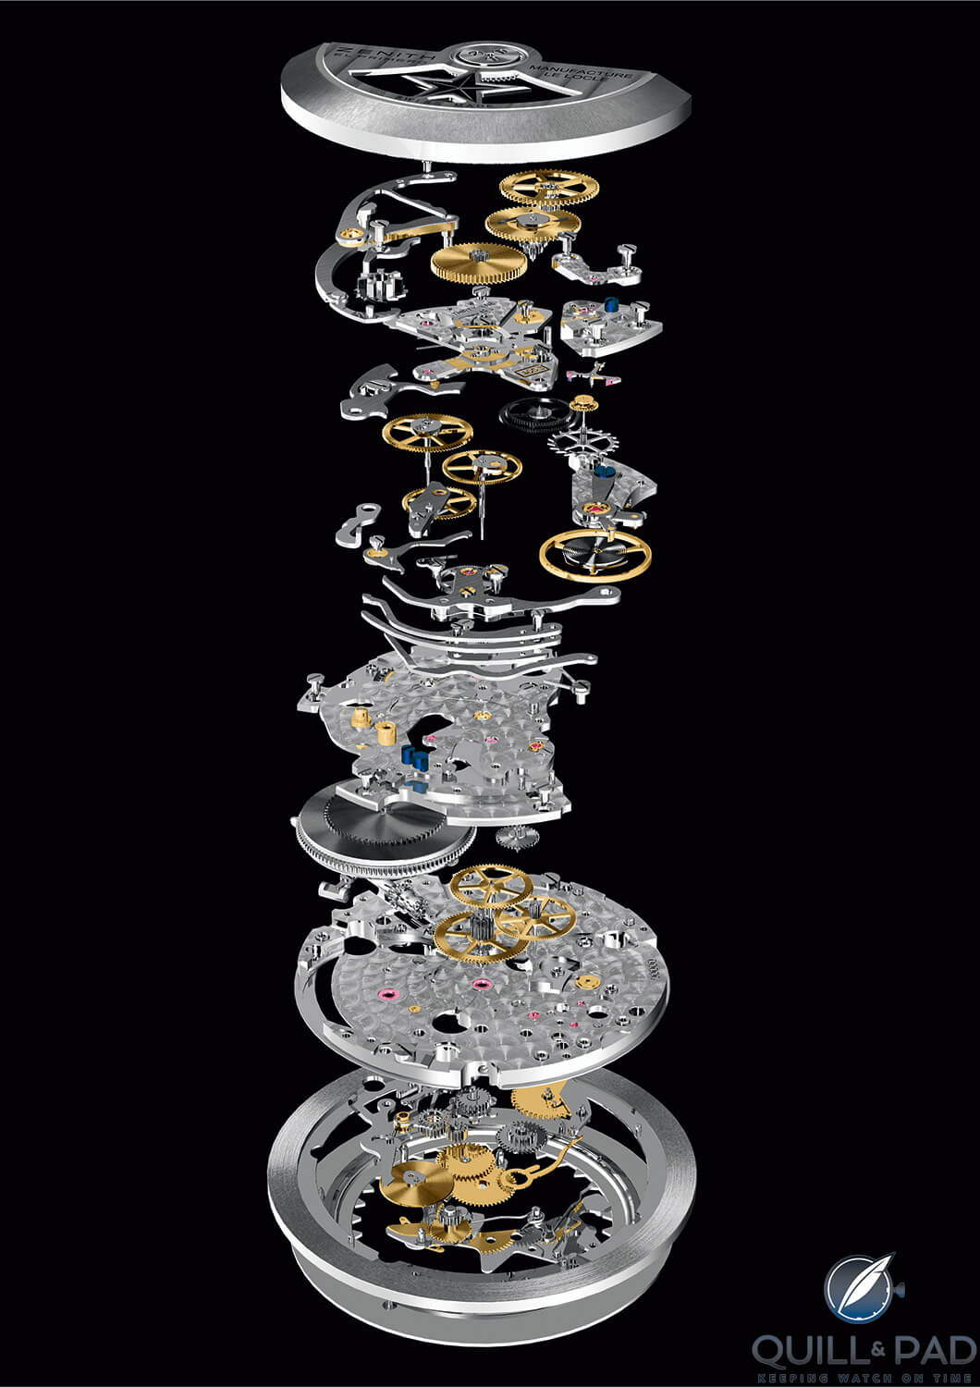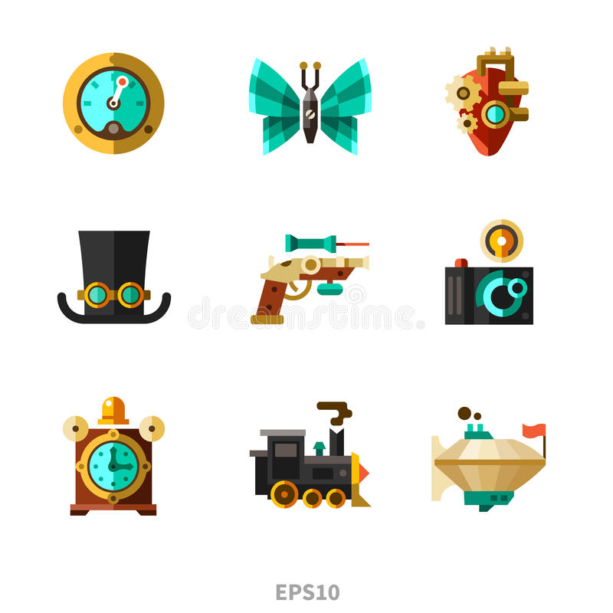

# 

# Tech

We are using the Unity game engine for the game.

Are you using any plug-ins or packages?

Are there any technical considerations, requirements, or constraints?

# Audio

SATISFYING

What is the game’s audio direction?

Are there any audio considerations, requirements, or constraints?

# UI

There is no need to display lives, score or time, so the UI can be effectively neglected during gameplay.

On the Main and Pause menus, UI should be minimal and straightforward.

What style will the UI be?

What UI elements will be needed in the game?

What information must be relayed to the player?